VIT UNIVERSITY

APPLICATIONS OF DIFFERENTIAL EQUATIONS

MAT2002

experiment-2

Faculty: Dr. Mellacheruvu Naga Srinivasu slot:L49+L50 venue:SJT319

**NAME: NILADRI SRICHANDAN SAHOO REG.NO:17BEE0048**

**DATE:04/01/2018**

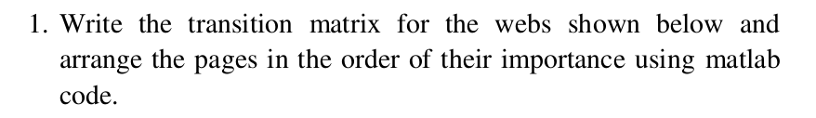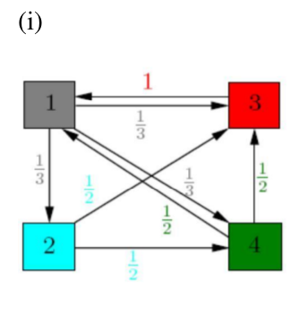

**code:**

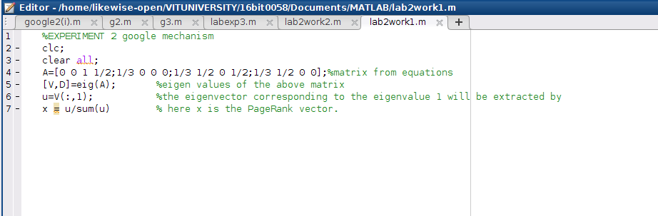

**output:**

**II)**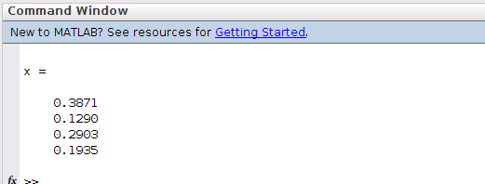

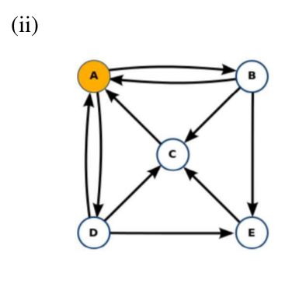

**code:**

output: